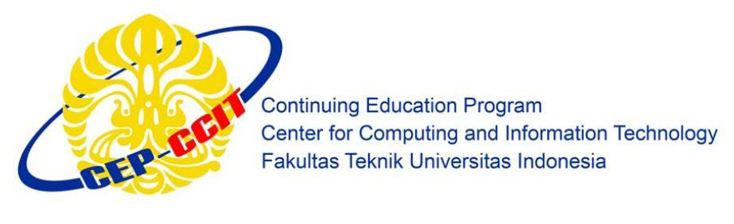**Information Search and Analysis Skills**

**(ISAS)**

**TECHNOLOGY ARCHITECTURE**

**OF MOTHERBOARD**

Name : 1. Andika Saputra

2.Ugi Ispoyo Widodo

Faculty : Mrs. Emma Yulianti ST, MM

Semester : 3

Quarter : 5

Class : 3SC4

**Gedung Pascasarjana Lt. 3 Fakultas Teknik Universitas Indonesia**

**Kampus Baru UI Depok 16424**

**PREFACE**

All praise and gratitude writer prayed to Allah the Almighty God who has given His grace and guidance. So we do not experience barriers to the completion of a paper entitled "Technology Architecture of Motherboard". In this occasion, in the writing of this paper the authors get a lot of support from various parties, therefore, the authors also wish to thank the infinite:

1. Our parents, that always giving us good support to the support in the form of moral and material support.
2. Dr. Aries Subiantoro, ST.,M.Sc. as Director of CCIT-Faculty of Engineering, University of Indonesia.
3. Mrs. Emma Yulianti ST, MM, as Our Lecture Course that has a lot to provide guidance, direction and inputs in the manufacture of this paper as well as in other fields.
4. Friends in arms that also specifies the motivation is always in the form of exchange of ideas, encouragement and other things in order to manufacture this paper.
5. Others Peoples who take holders who also helped in making this paper.

The authors recognize that this study is far from perfect and there are still many short comings, therefore the authors expect criticism and constructive suggestions to the perfection of this writing. Hopefully, this task can be useful and beneficial to readers and other researchers, especially students ofCCIT-Faculty of Engineering, University of Indonesia and others who read this paper.

Depok, September 2015

The Author

Table of Contents

CHAPTER I 1

INTRODUCTION 1

I.1. Background 1

I.2. Writing Objective 1

I.3. Problem Domain 2

I.4. Writing Methodology 2

I.5. Writing Framework 2

CHAPTER II 4

BASIC THEORY 4

II.1 Definition of Hardware CPU 4

II.2 Definition of Motherboard 4

II.3 History of Hardware CPU 5

II.4 History of Motherboard 6

CHAPTER III 8

PROBLEM ANALYSIS 8

III.1. MOTHERBOARD Component And Function 8

III.2. MOTHERBOARD Port And Function 22

CHAPTER IV 27

CONCLUSION AND SUGGESTION 27

IV.1. Conclusion 27

IV.2. Suggestion 27

Bibliography 28

# Table of Figures

Figure 2.1 Motherboard..............................................................................................................4

Figure 3.1 Diagram Block Of Motherboard...............................................................................8

Figure 3.2 Chipset......................................................................................................................9

Figure 3.3 Southbridge and Northbridge..................................................................................11

Figure 3.4 The Difference of Northbridge & Southbridge.......................................................12

Figure 3.5 CPU Socket.............................................................................................................13

Figure 3.6 PCI Slot…...............................................................................................................14

Figure 3.7 AGP Slot.................................................................................................................15

Figure 3.8 Memory Slot……...................................................................................................16

Figure 3.9 Heat Sink ................................................................................................................16

Figure 3.10 Power Connector...................................................................................................17

Figure 3.11 SATA Slot….........................................................................................................18

Figure 3.12 IDE Slot ...............................................................................................................19

Figure 3.13 BIOS………….....................................................................................................19

Figure 3.14 CMOS………………...........................................................................................20

Figure 3.15 Capacitors……….................................................................................................22

Figure 3.16 Port of motherboard…..........................................................................................23

Figure 3.17 Post Sound…………............................................................................................25